DARS Pre-Employment Transition Services (Pre-ETS) Update for ESOSC
10/11/2022
This update on Pre-ETS is primarily focused on Summer Pre-ETS activity with vendors. The following authorization data (See Table: Summer 2022 Pre-ETS Expenditures) is reflective of all Pre-ETS activities supported by vendors between 5/01-08/31/2022 (includes Job Exploration Counseling, Workplace Readiness Training, Work-Based Learning Experiences, Instruction in Self-Advocacy, and Counseling on Postsecondary Education & Training Opportunities).
Summer 2022 Pre-ETS Expenditures
DRS District | Authorizations | Expenditures | # of Students
Capitol | 227 | $141,000 | 106
Skyline | 301 | $166,000 | 94
New River | 460 | $439,000 | 159
Southwest | 227 | $147,000 | 67
Hampton Roads | 346 | $193,000 | 189
Northern | 613 | $256,000 | 224
Total | 2274 | $1,342,000 | 870

Statewide Summer Work Experiences (Student Count) by Vendor
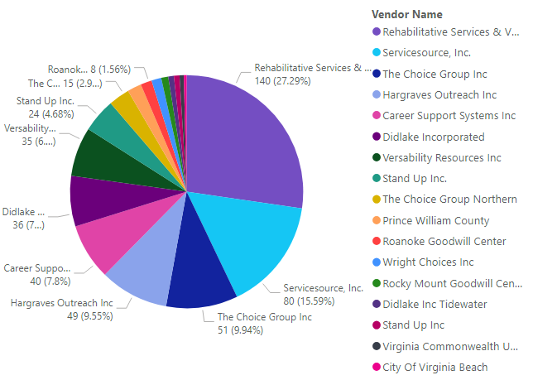

Pre-ETS Vendor Needs
There is a significant need for Pre-ETS vendors who can support both short-term work-based learning experiences (e.g. work site visits/tours, informational interviews, job shadows, short-term job tryouts, etc.) and 3-8 week work experiences supported by skills trainers. Although there was an increase in work experience activity this past summer (from 350 students to 490), there were still numerous reports of students who were unable to participate in a work experience due to a lack of vendors to support them. In general terms, there are more significant gaps and lack of options in rural regions of Virginia so I encourage outreach and discussion from ESOs who can potentially serve offices in our Southwest, Skyline, New River, and more rural parts of our other districts. If you have existing relationships and ties to communities (e.g. with local education agencies/schools) where you are not currently receiving Pre-ETS referrals, please contact Martin Kurylowski as this might be a good opportunity to build capacity and expand services in those areas. Virginia DARS welcomes the ESOSC’s support to problem-solve our capacity issues in this critical Pre-ETS service category!

Thank you,
Martin Kurylowski
Transition and Education Services Coordinator, VA DARS

